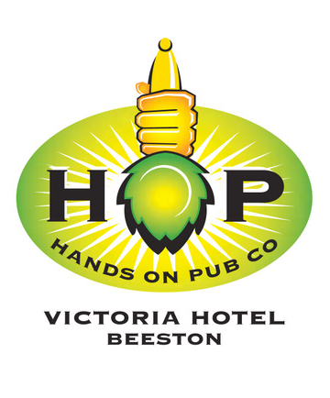
The Victoria Hotel
85 Dovecote Lane
Beeston
Nottingham
NG9 1JG

Tel: 01159254049
Fax: 01159223537
E-mail: info@victoriabeeston.co.uk
Website: www.vichotelbeeston.co.uk

Conference Rooms Available for Hire
The Victoria, famed for its hospitality, great quality drinks and meals is proud to announce three new conference room facilities available for booking. Newly refurbished and modern in features and arrangement, our new conference rooms are perfect for both small business meetings and large group presentations.
£60
Half Day
£120
Full Day
Conference Room A
Maximum 8 Person Capacity
Hot and Cold Refreshments Available by Arrangement
£300
Full Day
£150
Half Day
Book Today at the Bar or call us on (0115) 925 40 49
Book Today at the Bar or call us on (0115) 925 40 49
Conference Room C
Up to 30 Person Capacity dependant on Layout
Requirements
Hot and Cold Refreshments Available by Arrangement
Conference Room B
Maximum 8 Person Capacity
Hot and Cold Refreshments Available by Arrangement
Book Today at the Bar or call us on (0115) 925 40 49
£120
Full Day
£60
Half Day

